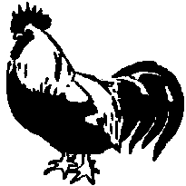

The Dorking Breed Club

Hon. Sec. Mrs. V. Roberts BVSc MRCVS
Heather Bank Barn, Hillings Lane
Menston, Nr. Ilkley,
W. Yorks. LS29 6AU. vicvet@hotmail.co.uk

APPLICATION FOR MEMBERSHIP OR SUBSCRIPTION RENEWAL (delete not applicable)

Name……………………………………………………………………………………………………………………...

Address…………………………………………………………………………………………………………………...

……………………………………………………………………………..Postcode……………………………………

Telephone…………………………Email…………………………………………………………Date………..………

Colours kept and approximate numbers………………………………………………………………………………….

Source of stock, if known………………………………………………………………………………………………..

Newsletters are issued January, April and August. Membership subscription is £7 per year UK, £7 overseas (online publications only), payable in April annually (more than one year at a time saves the Club money and is much appreciated). Please make cheques payable to The Dorking Breed Club and from Europe, send Euros as cash.
BACS (most economical for the Club): sort code 09-07-24, account number 18038600, putting your name as the reference.
Or pay via Paypal on www.vicvet.com/dorkingclub. If you wish to receive Newsletters by email, please mark here

Your consent is needed for future communications. For consent, please mark here

Thank you for your support

